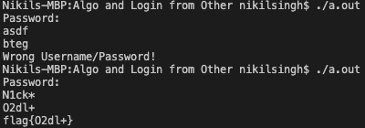Upon opening it as assembly, I found the string "O2dl+". I also found when running the program, it would output a slightly altered string compared to the input I placed. i.e. “asdf” produced “bteg” There was also a function called encryption. My first guess was it was some sort of Caesar cipher. I then tested more outputs and realised the value of the output was one less on the ASCII table. I then looked up the appropriate ASCII values and found the corresponding values to be "N1ck\*" surprisingly. It then also outputted the flag flag{O2dl+}.

